Create a Maven java project and select “skip skeleton architect type “ and then covert to TestNG

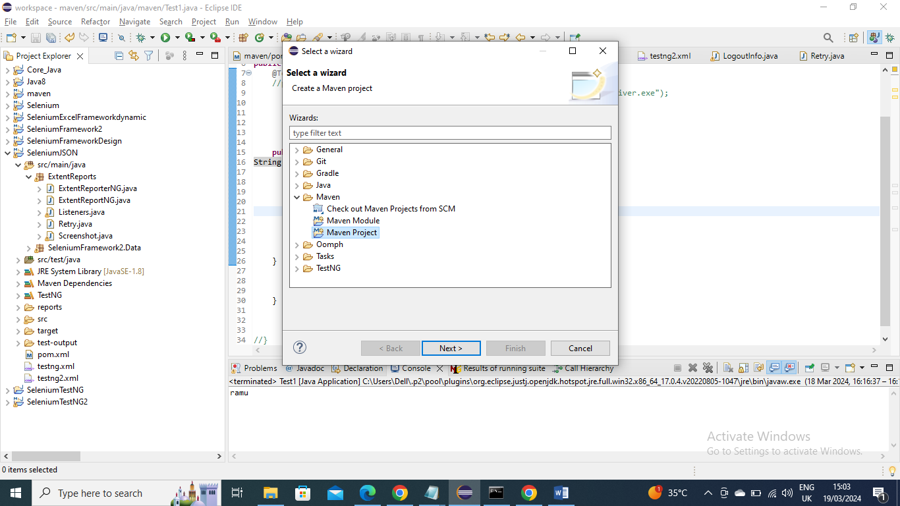

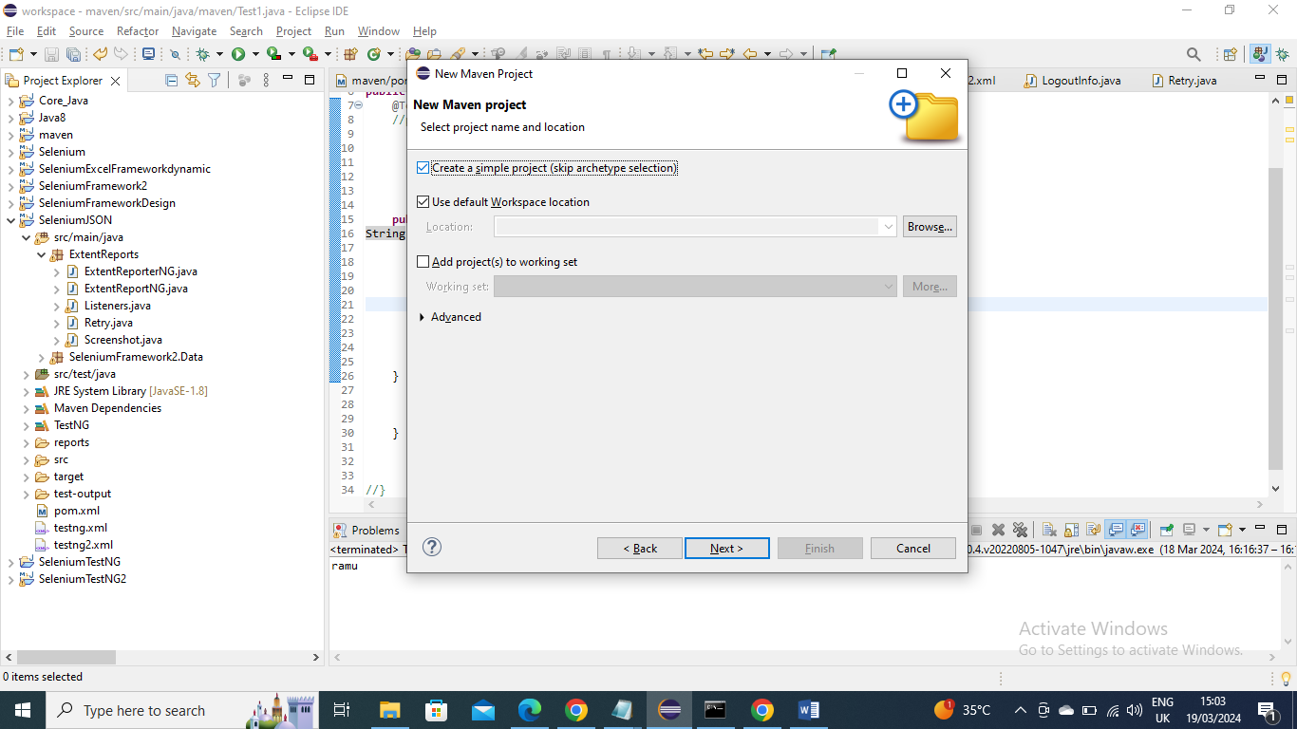

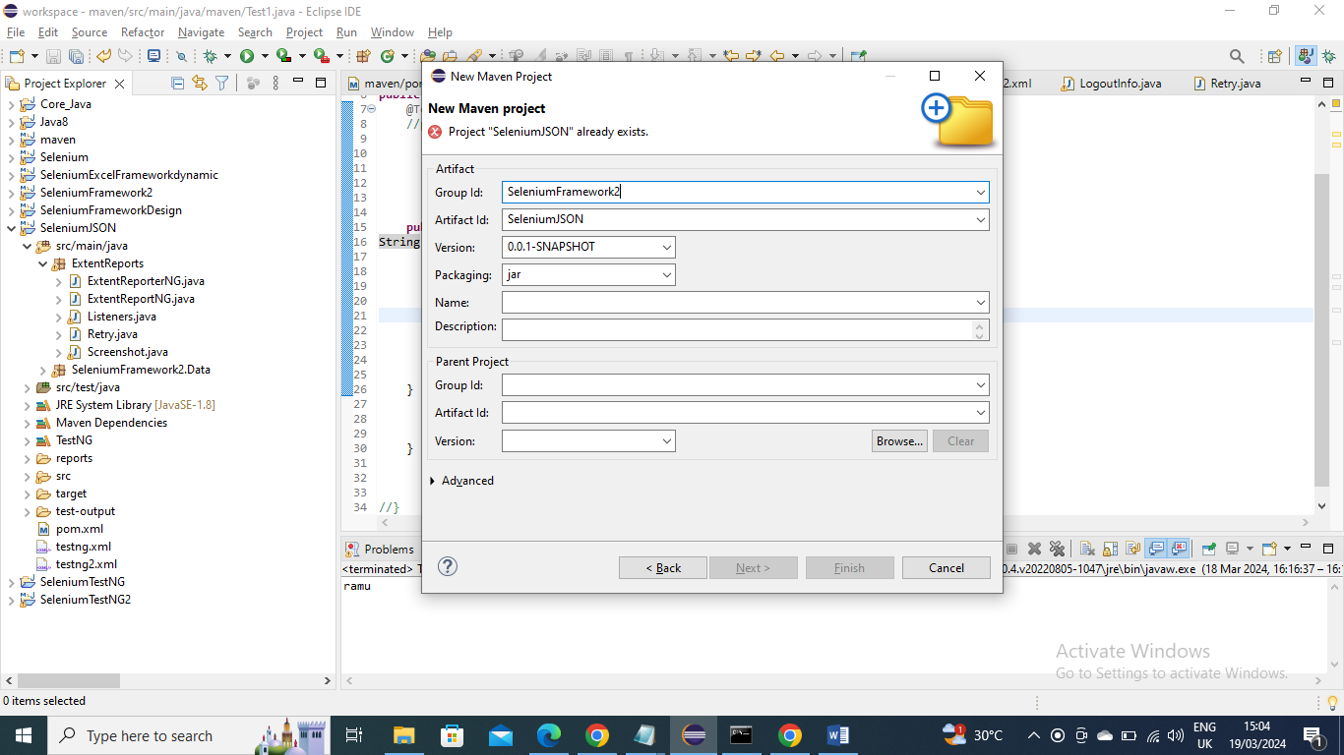

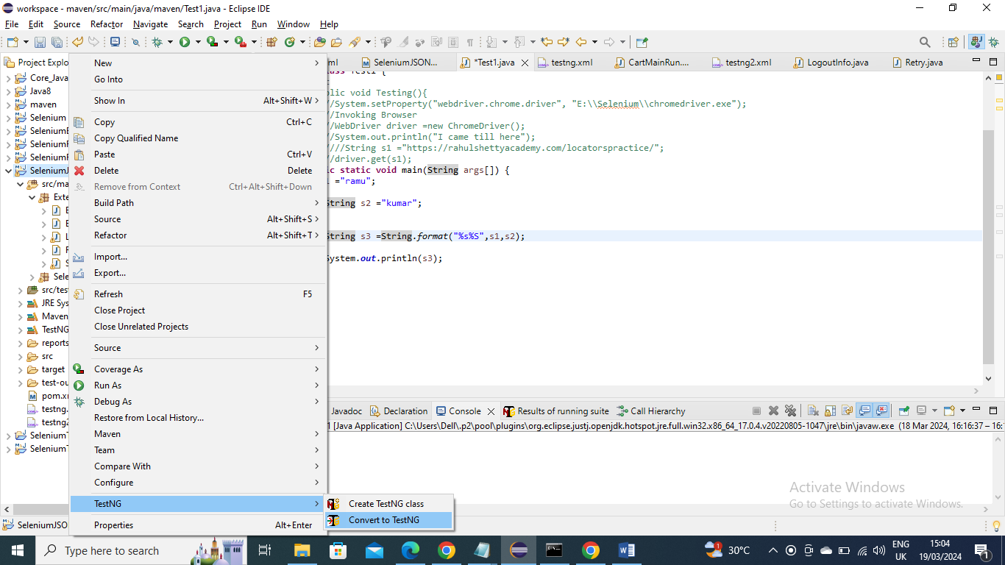

Objective of what we want to do –

The Objective of this Framework exercise is to Login by giving credentials and log out

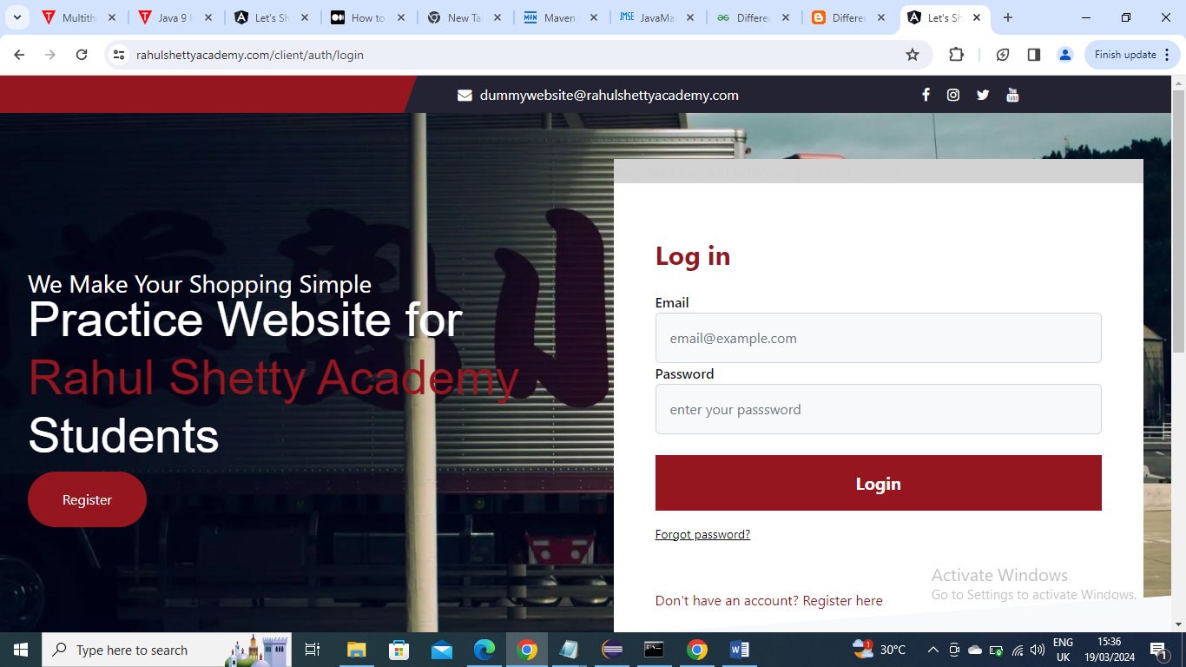

Lets start-

Add Selenium and TestNG jars

Selenium jar -

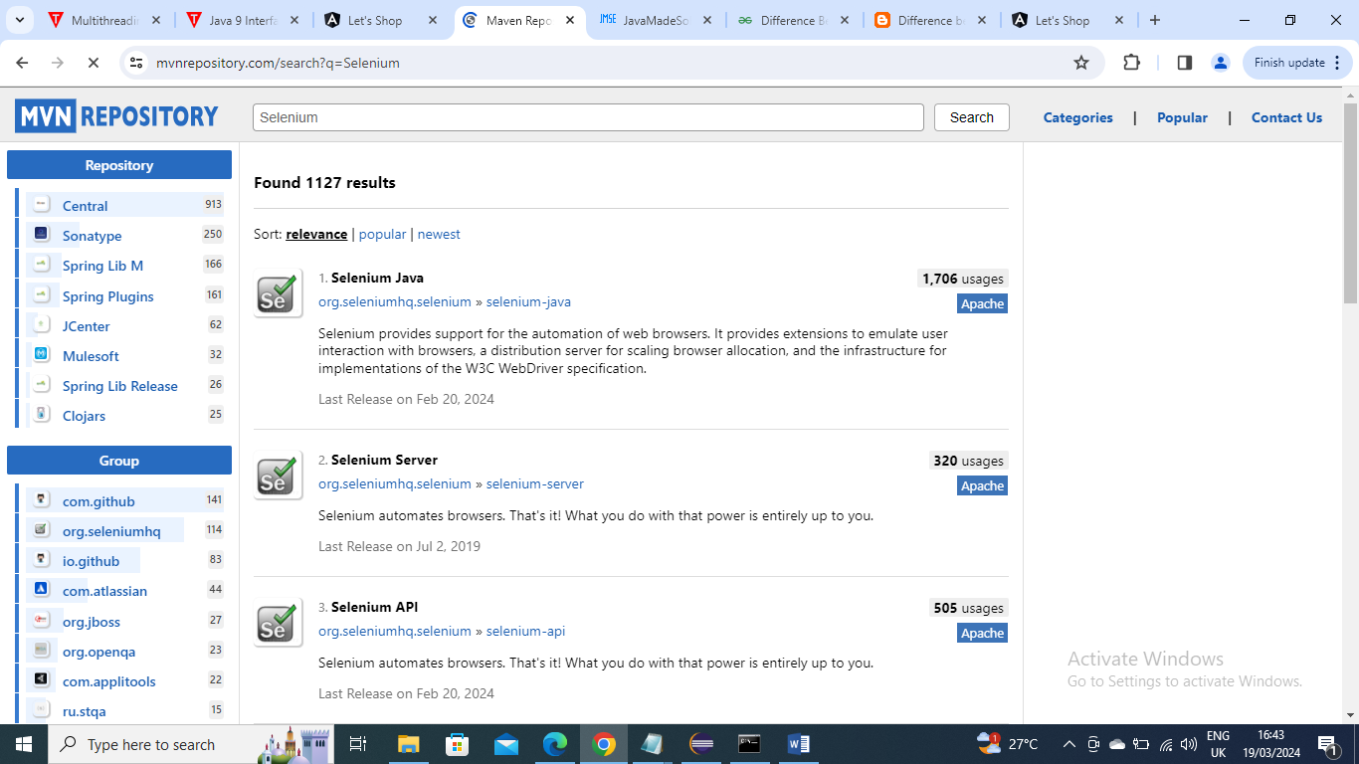

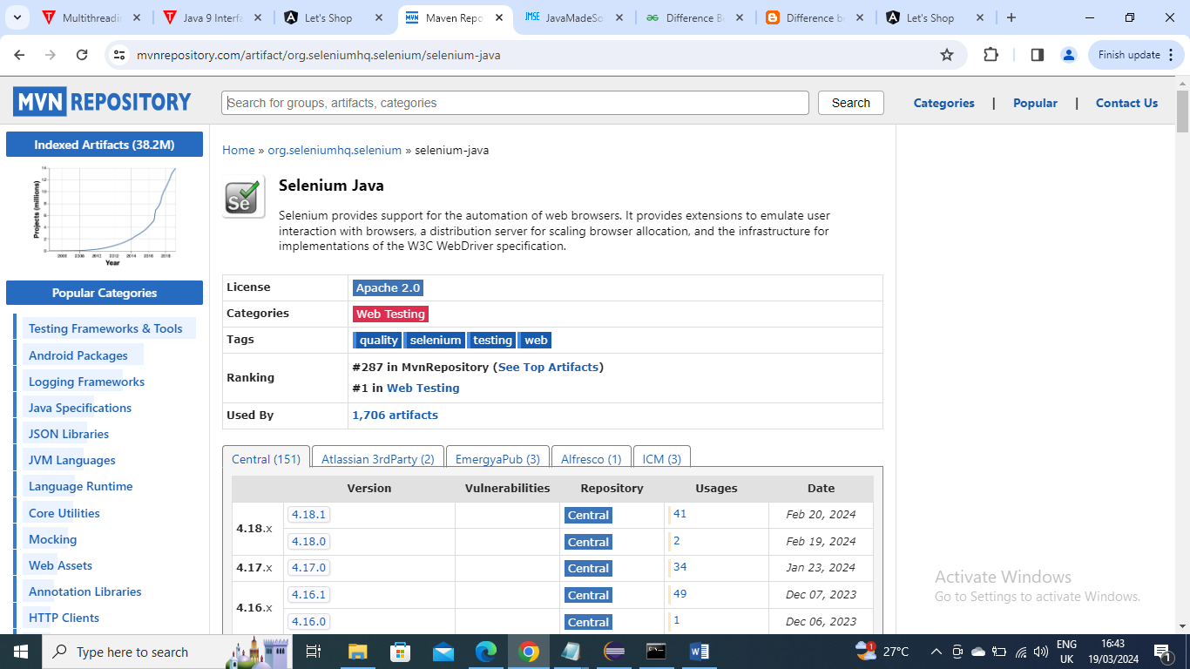

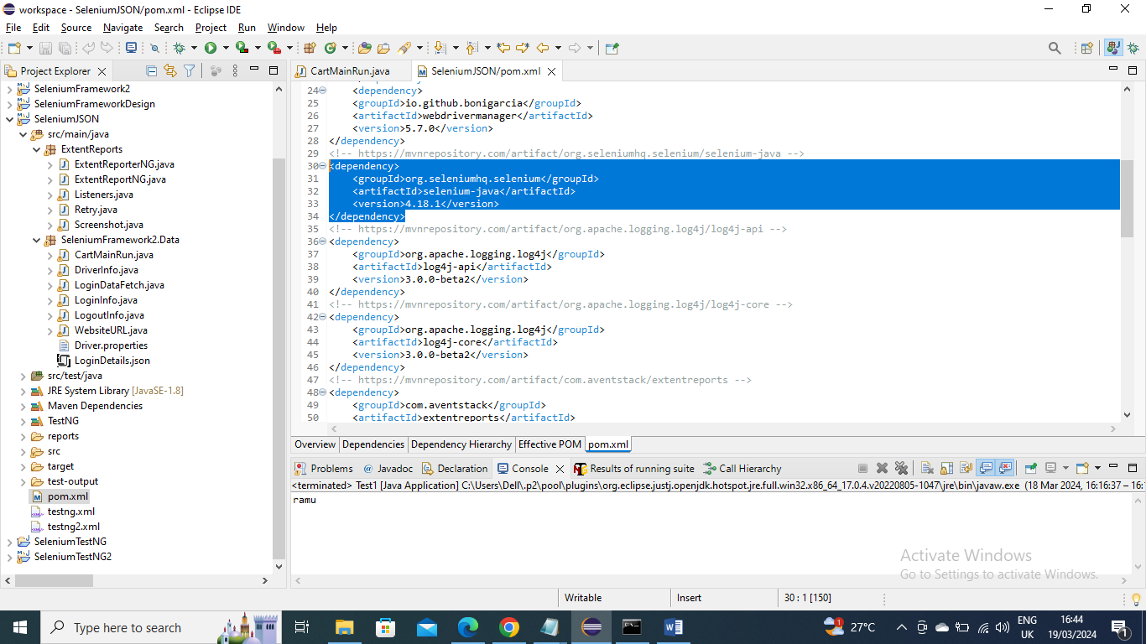

TestNG jar

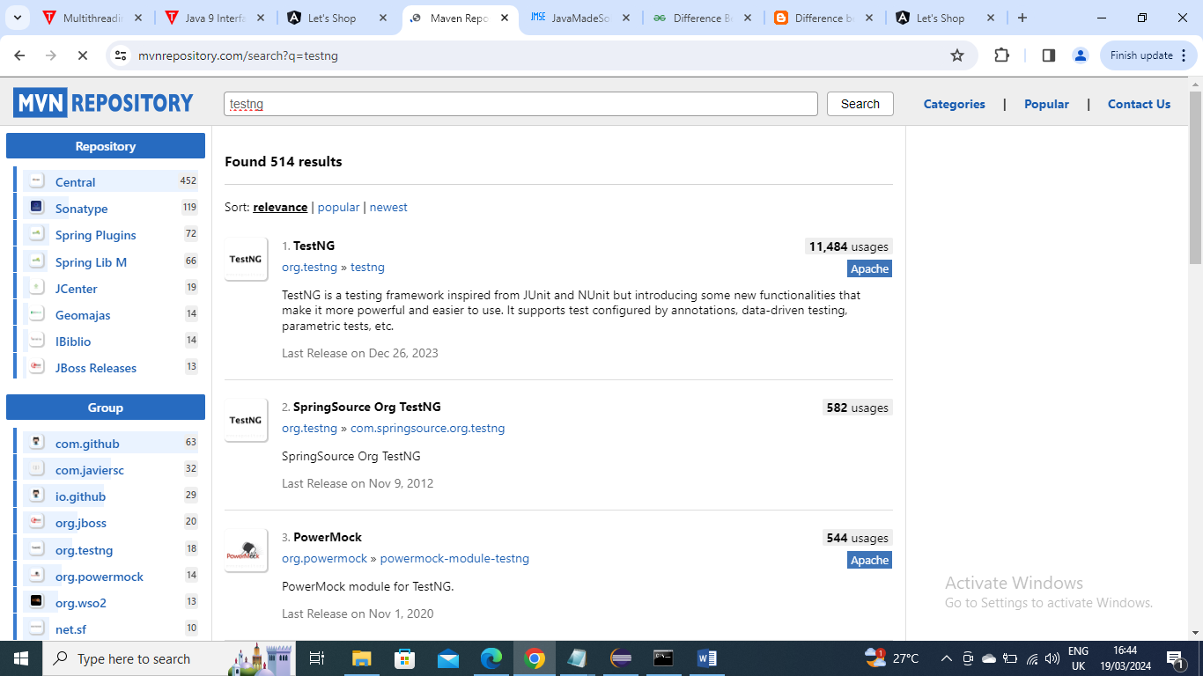

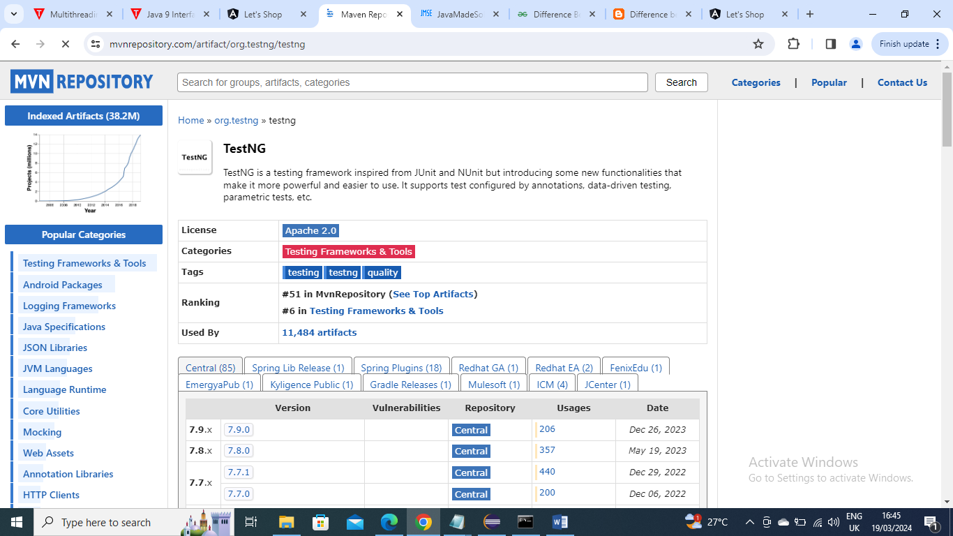

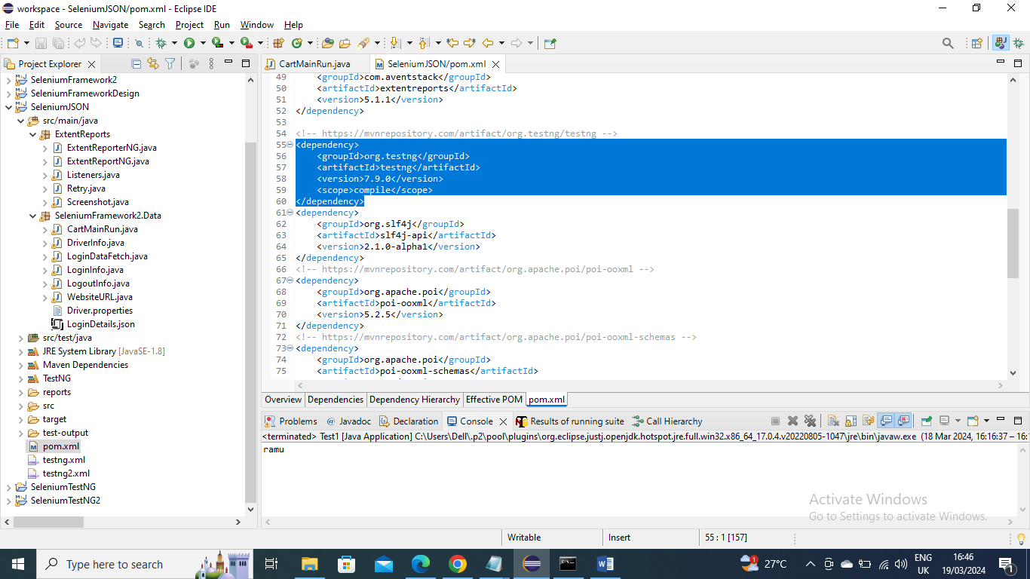

Driver class - First will create a class for getting the driver information. Generally we give the driver path like below

System.*setProperty*("webdriver.chrome.driver", "E:\\Selenium\\chromedriver.exe");

But we the problem would be when someone imports the code and run this this fails because that user might not have the driver in that location to avoid this we can have Webdriver jar

We can download by adding it as dependency and ask Maven to download it for us. You can search by “WebdriverManager bonigarcia” and add that dependency in pom file

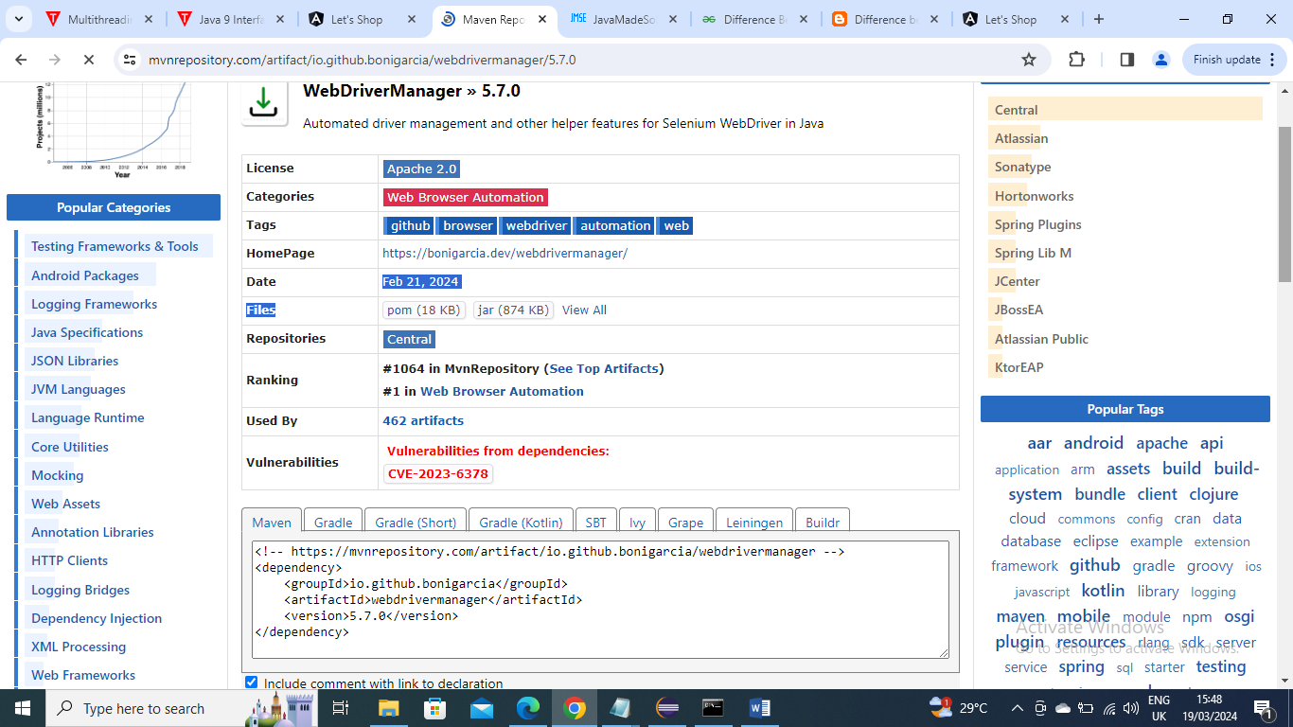

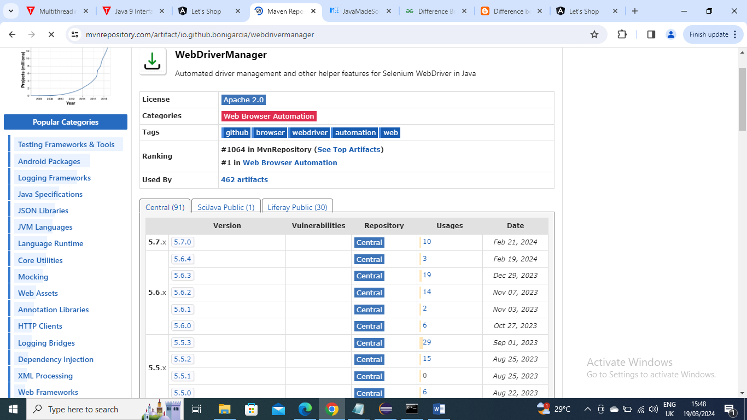



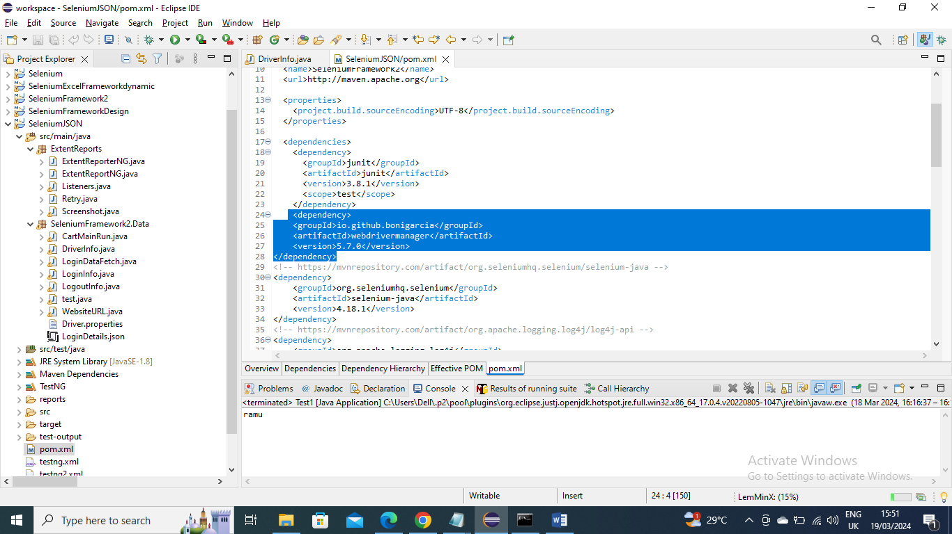

Driver class below – In below the browser information is taken from browser1 from driver.properties file and based on it will be give info to drive on which driver (chrome or firefox or edge…) it should run

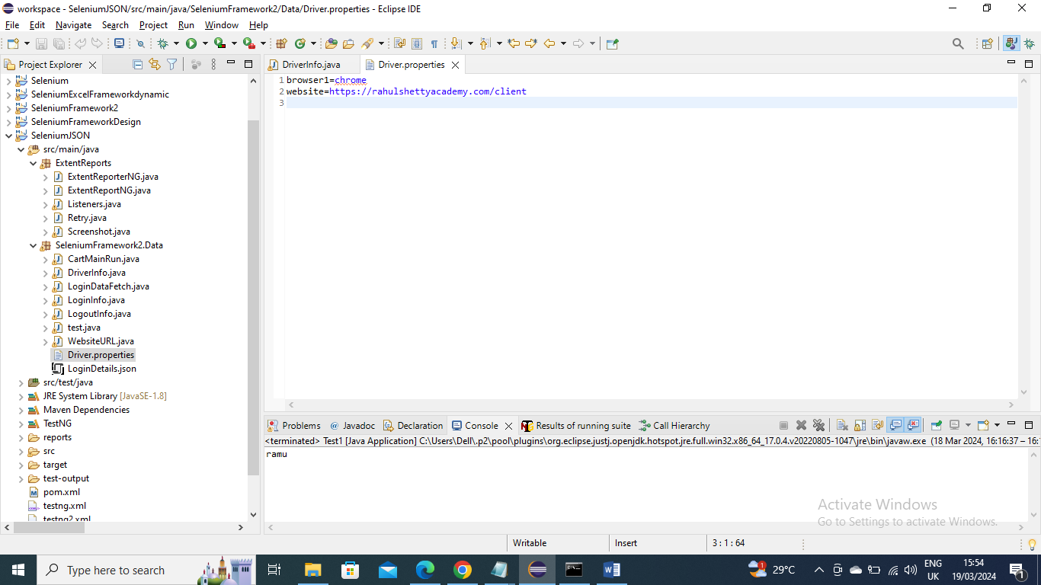

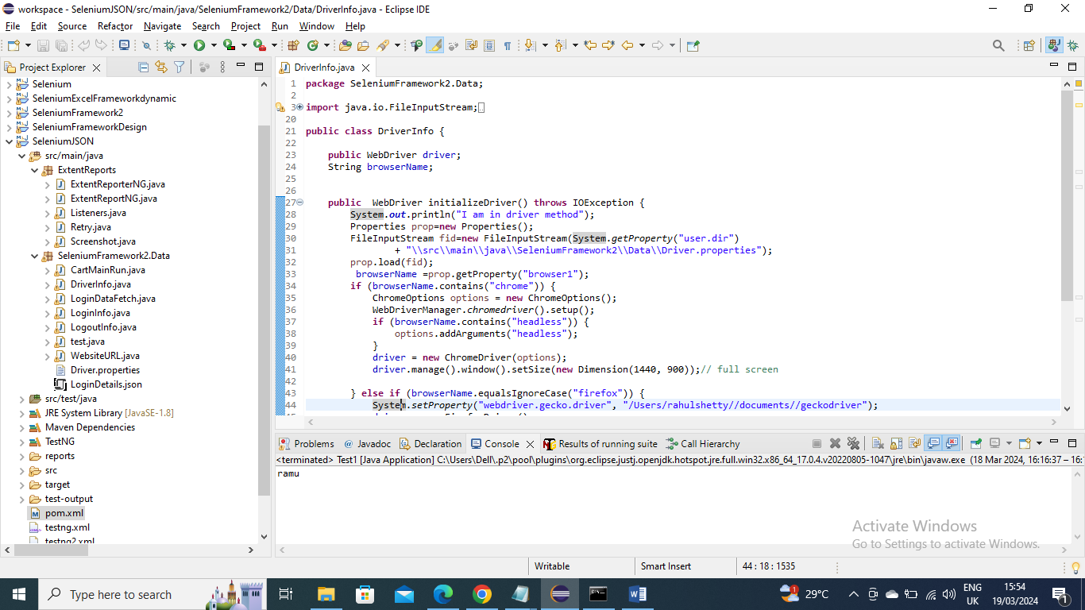

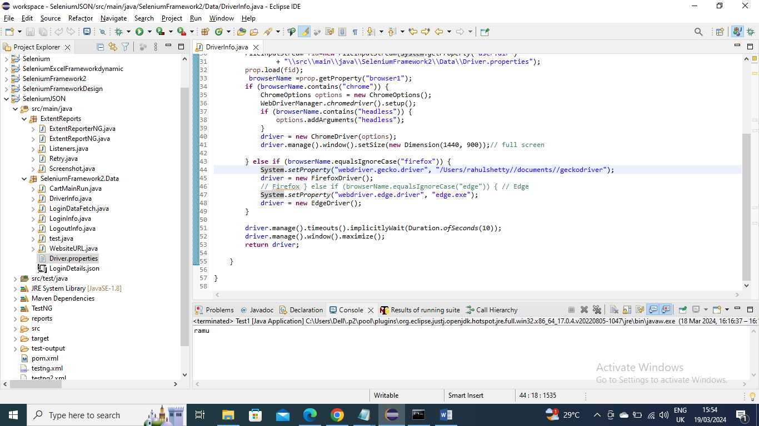

Website URL - In below the website URL information is taken from “website” from driver.properties file and returned back to called class

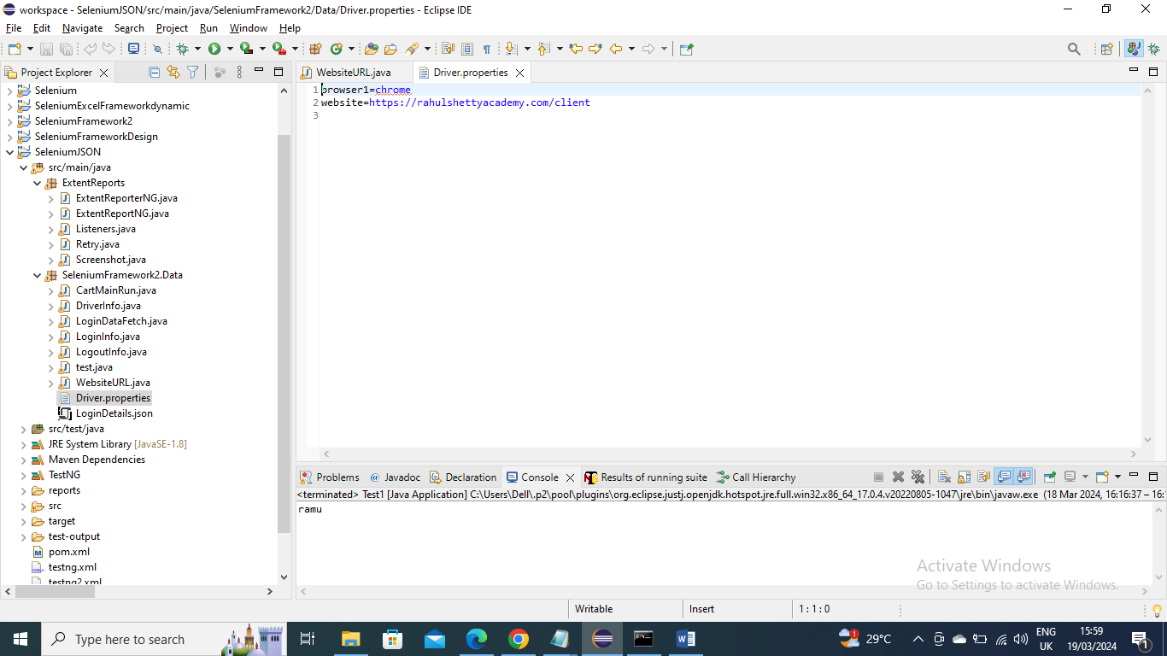

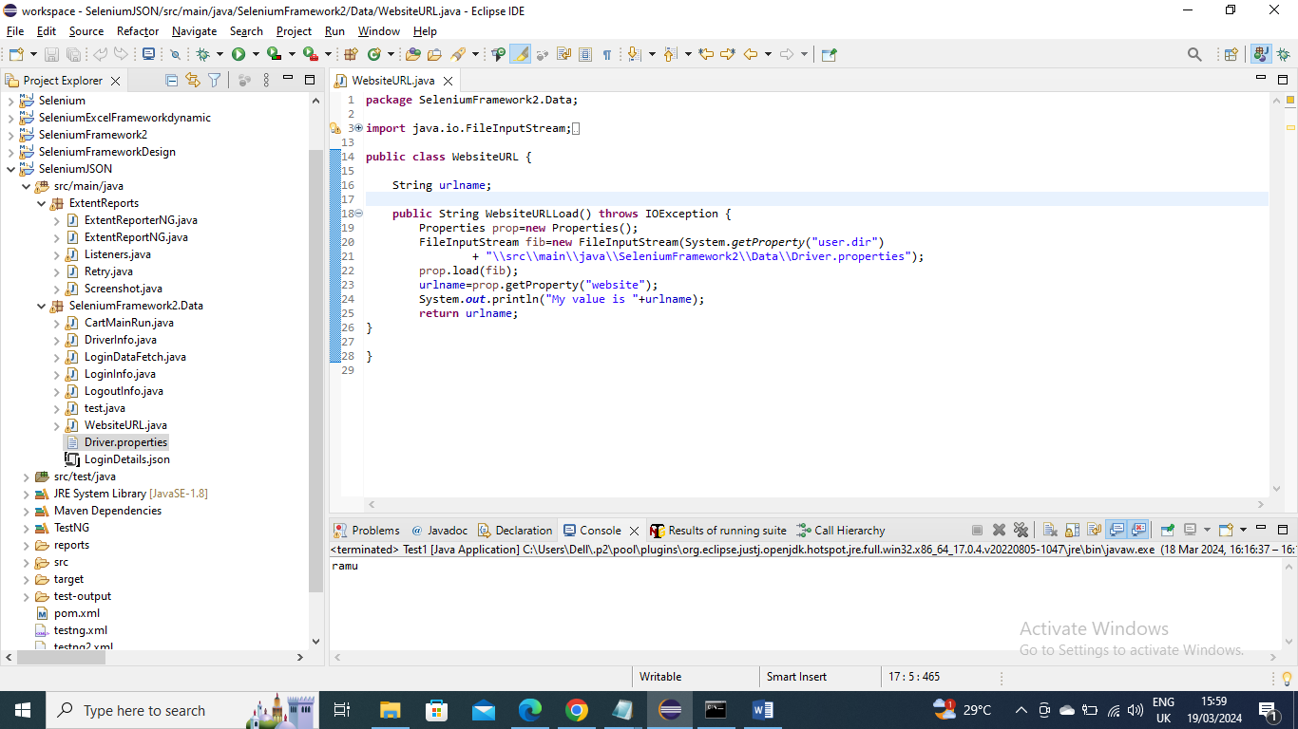

Login Credentials data fetch – the data is stored in LoginDetails.json file and program first converts from JSON to String and then String to HashMap and returns back to called program

We need to provide @Dataprovider and create a name so that we need to pass this values to the method which wants to receive them that method also needs to say I want to receive data by giving Dataprovider =”cartlogin”

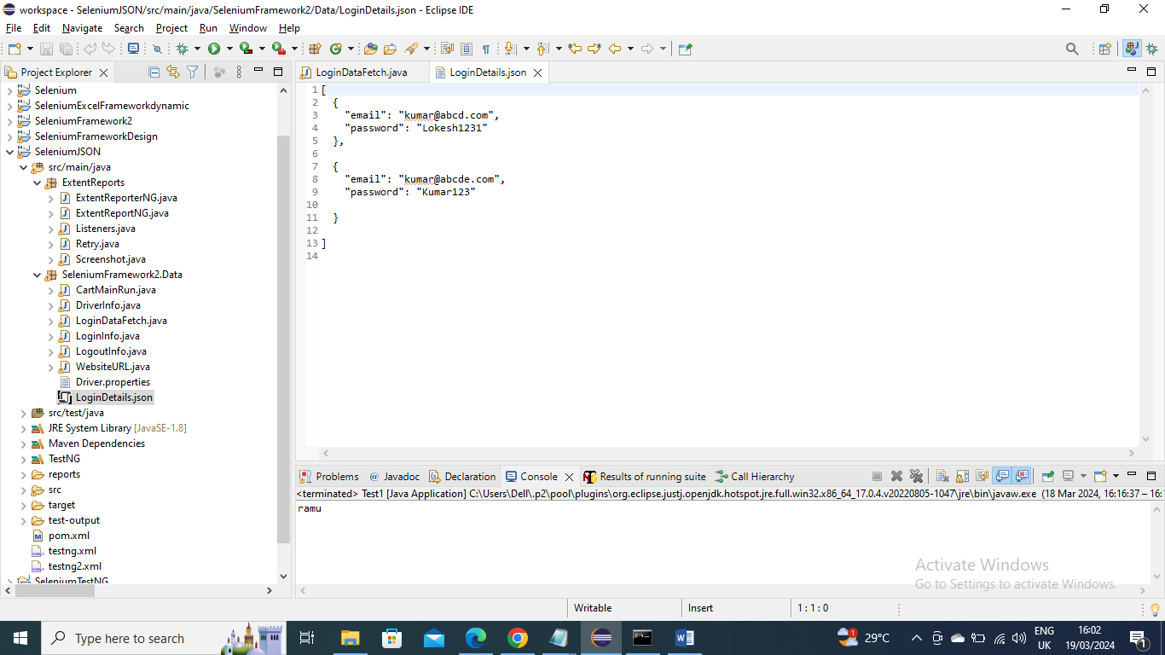

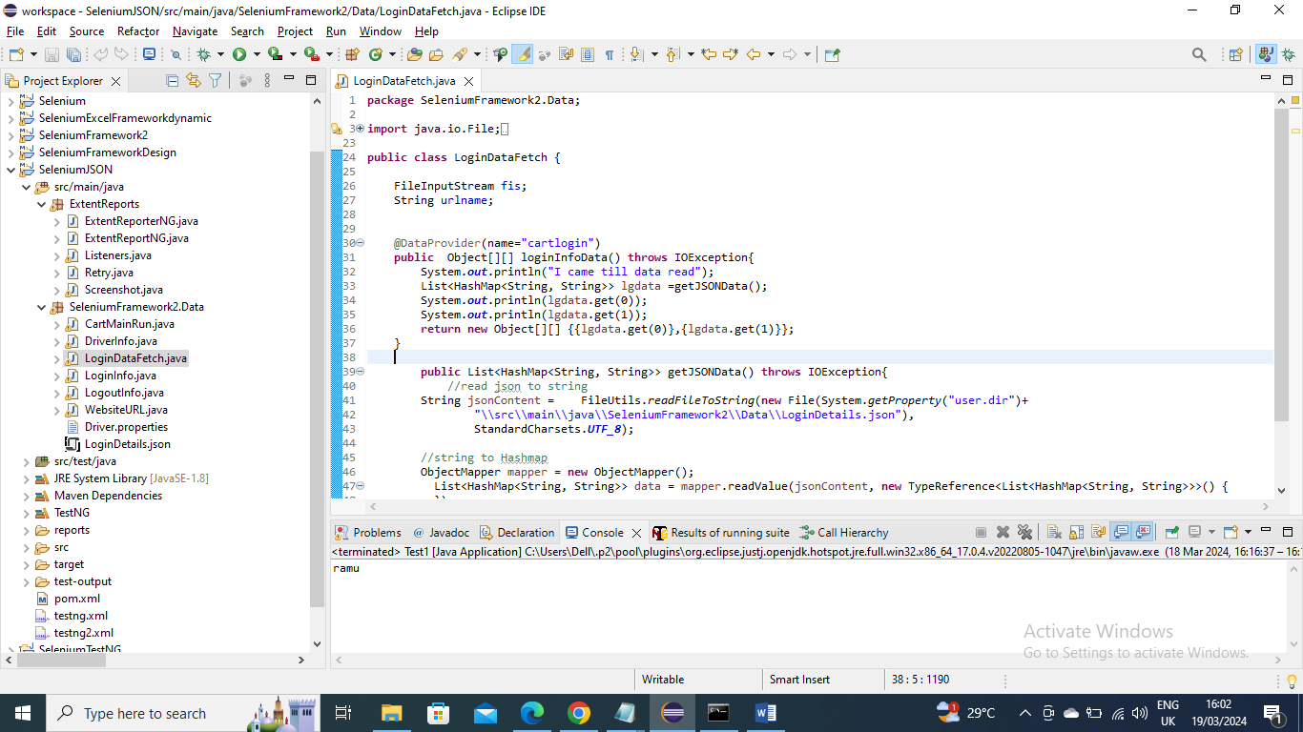

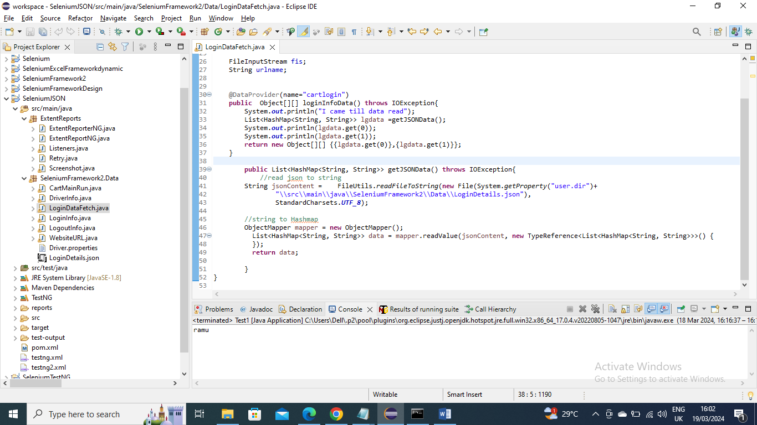

Login Information of paths (id’s) and clicking – In below program we provided the paths in @Findby and create a method Login where we give information on passing values and clicking it

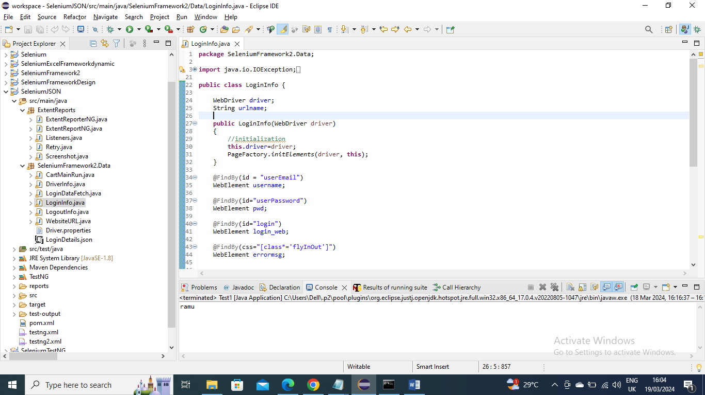

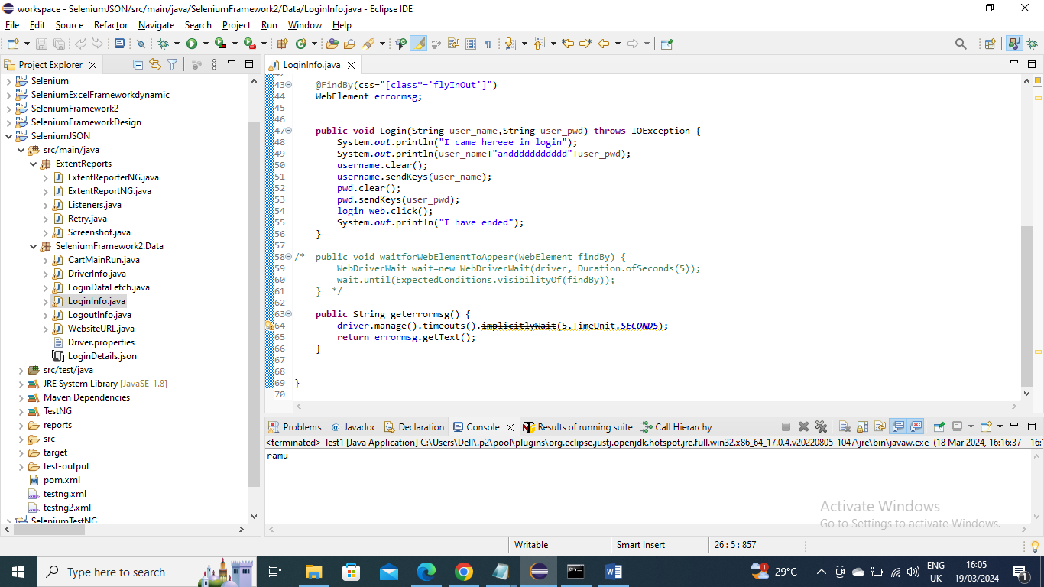

Logout Information – In below program we gave information on logout path(id) and method for sign out click

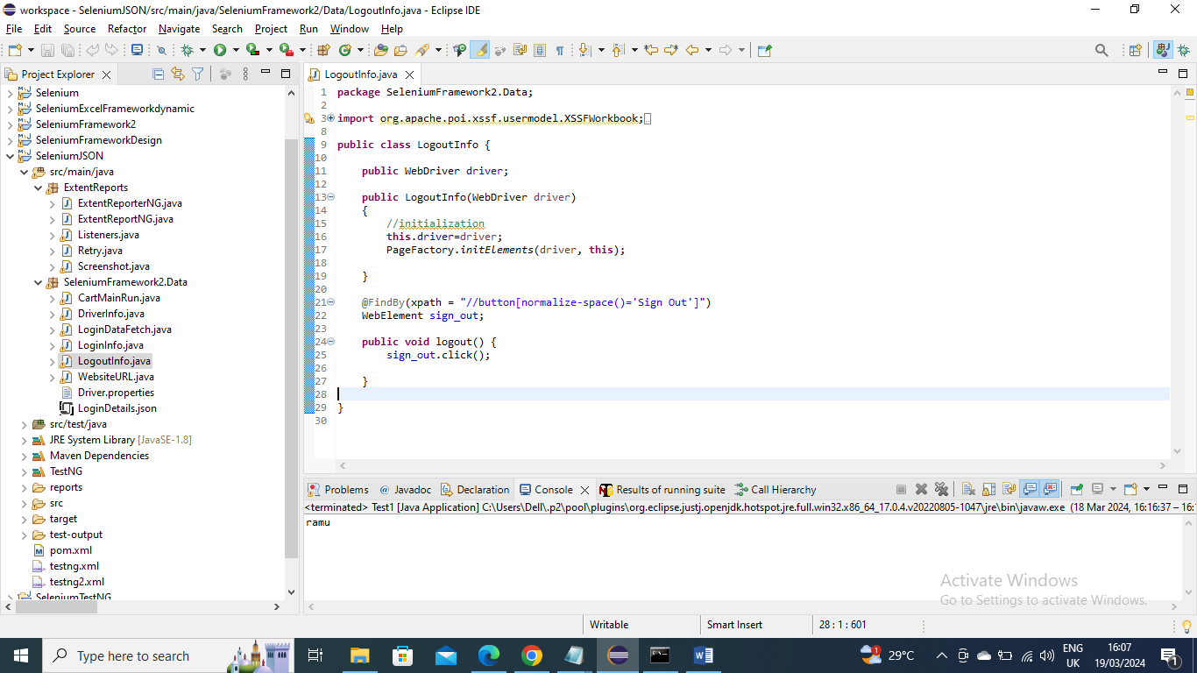

Main program (CartMainRun) – Now the below main program will instantiate wherever required and calls its methods to get the values and in another method to get the json values it give in @Test annotation the Data provider name and in which class it is present

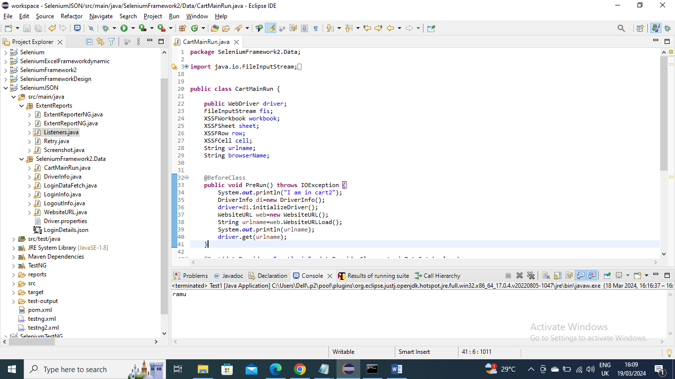

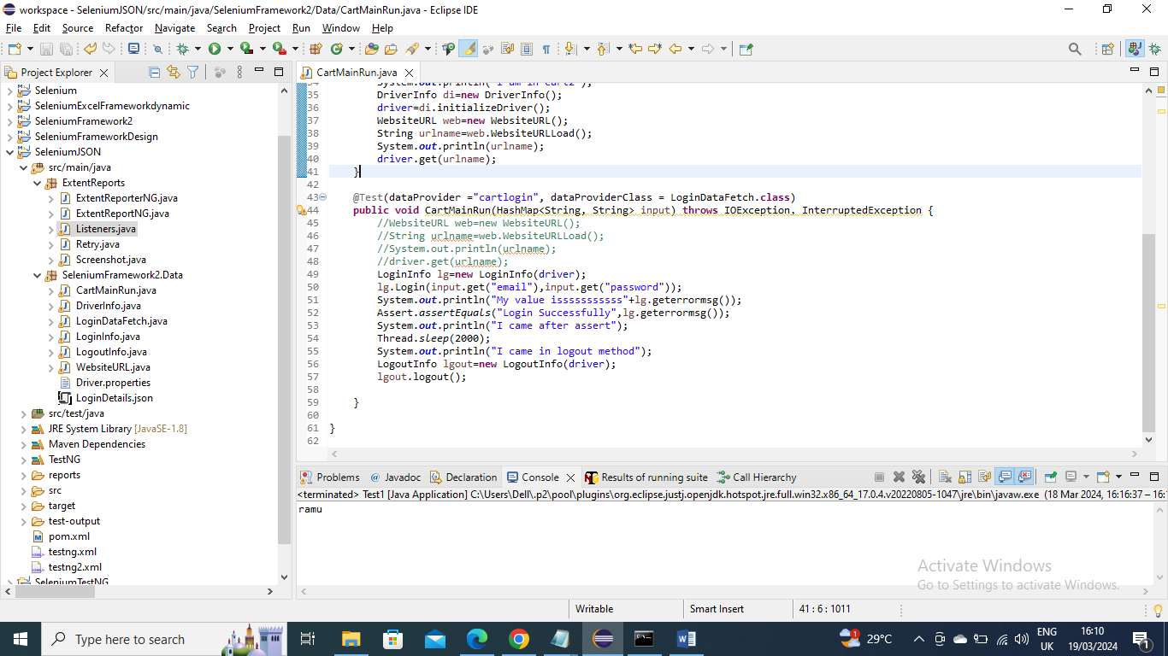

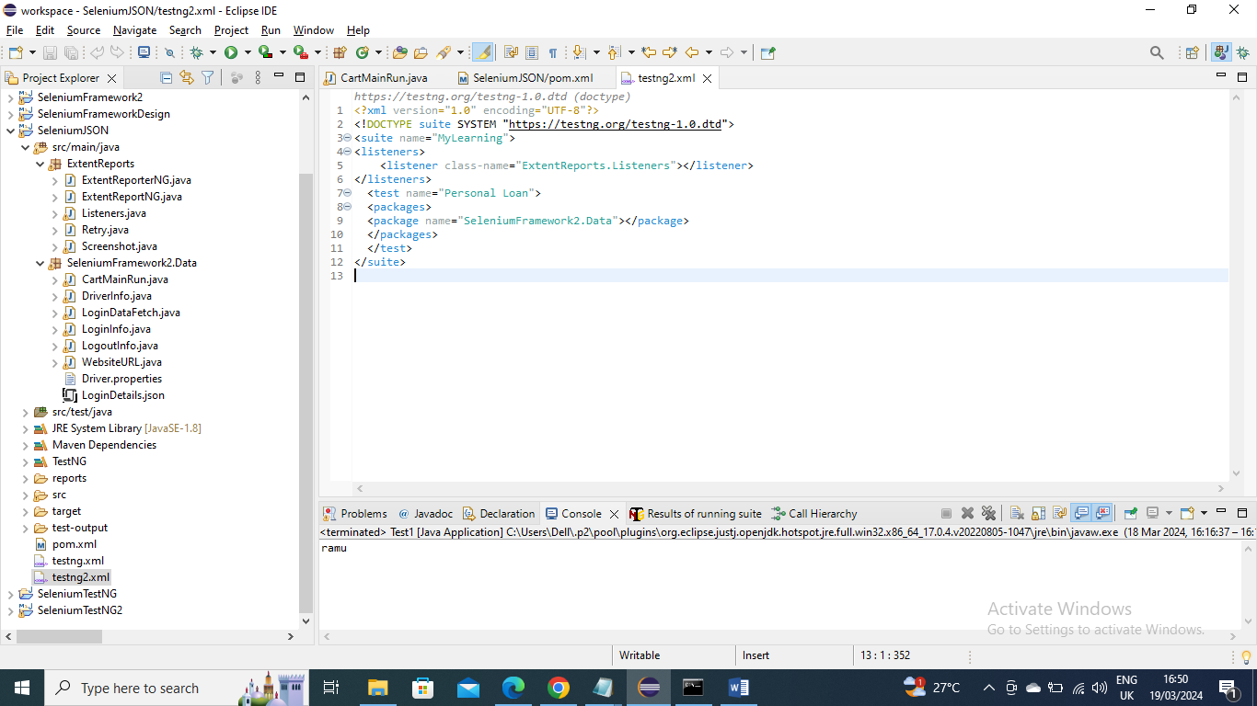

Run the Test – provide the Suite name and test name and give the class or package that you want to run and then right click and run as “TestNG Suite”



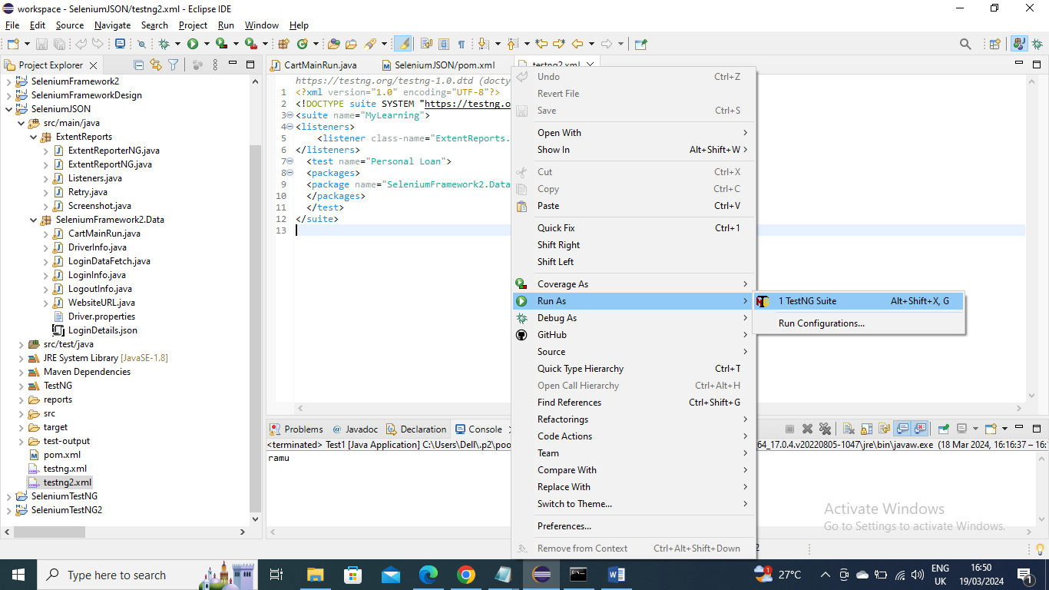

Getting errors - If getting errors of log4j or slf4j issues then add below dependencies

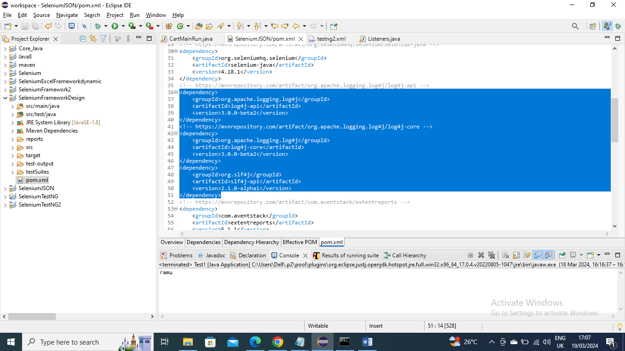

If getting error for Java 1.8 then add below plugin in pom file

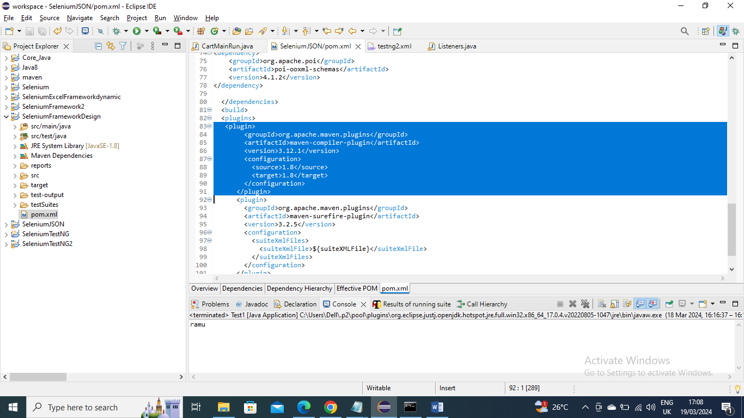

Retry - Now for any failed login you can do retry by creating a class and implementing IRetryAnalyzer and in this class you give the max retries if a test fails

And give in CartMainclass that retry name i.e. Retry = classname.class and run the XML

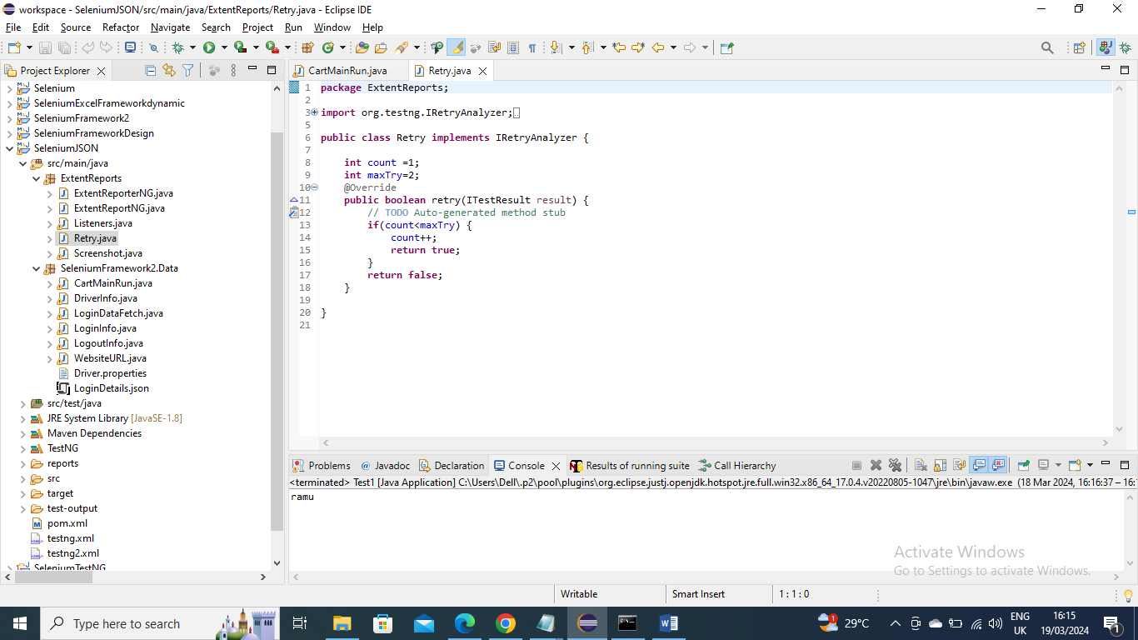

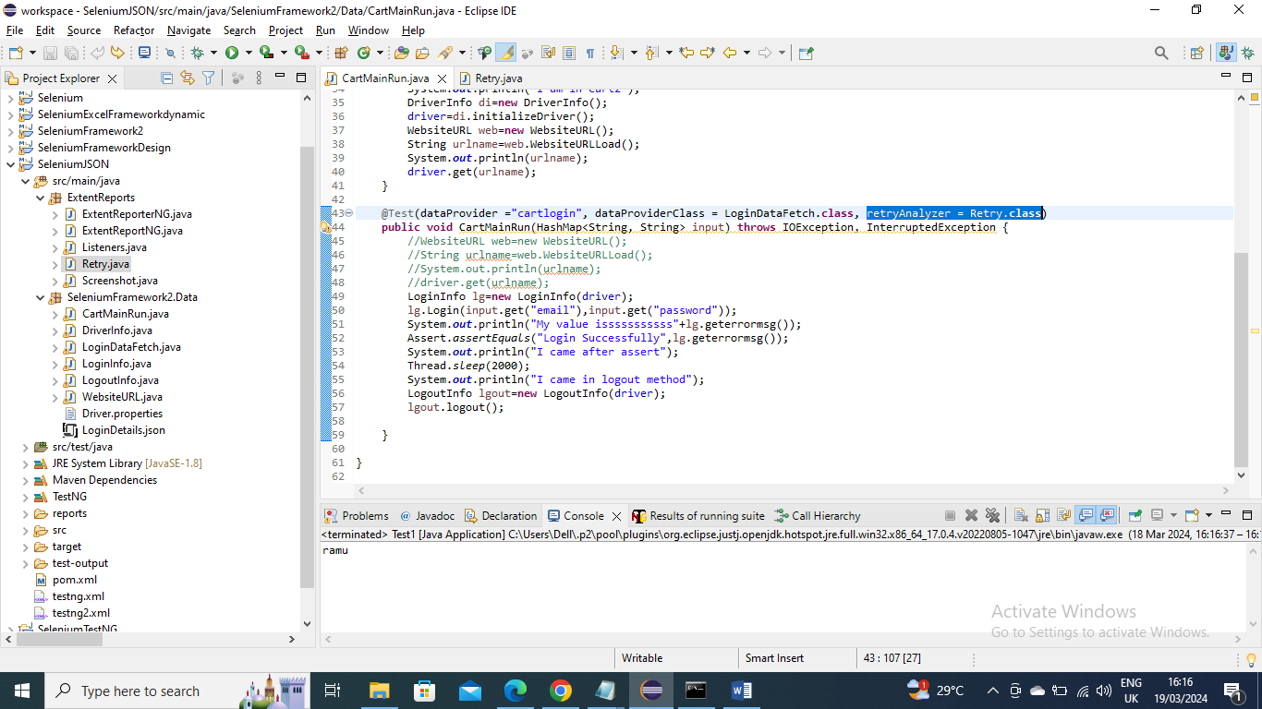

Screenshot – Below is the code for taking screenshot. When we want screenshot we have written in Listener class that we want it for test failure and I generates in report folder and also it gets generated or uploaded in extent report html page as well

Please note it is not necessary you need to mention in Listener class you can mention in main class or any class or any time you want screenshot

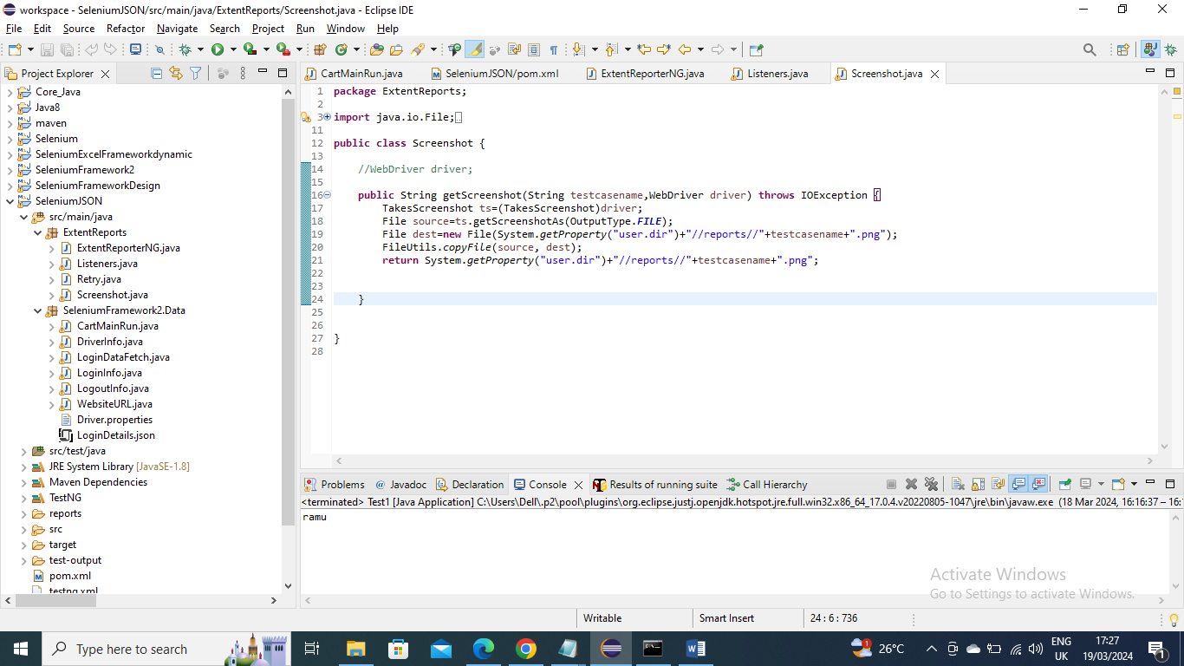

Extent Report – the below code is for extent report where the success and failure info is given in a html page (this html will be generated in reports folder as specified path in the code) with all details.

Now how this report will be generated we have provided in Listener class that for every test the html report for that test is created in html page

Before creating this class we need aventstack extent report jars where its dependency should be provided in pom file as below

Like I mentioned for screenshot Extent report it is not necessary you need to mention in Listener class you can mention in main class or any class or any time you want html report

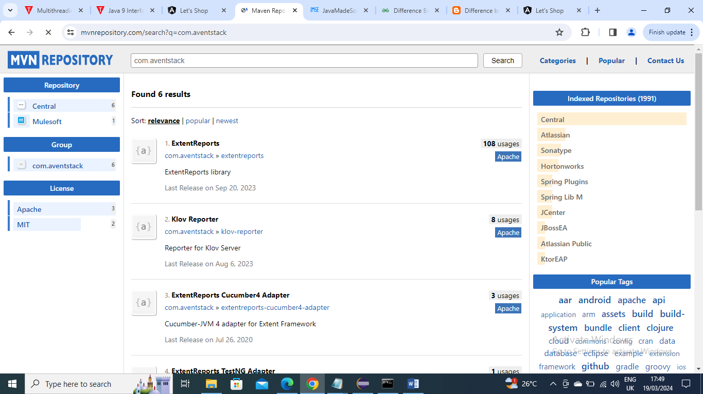

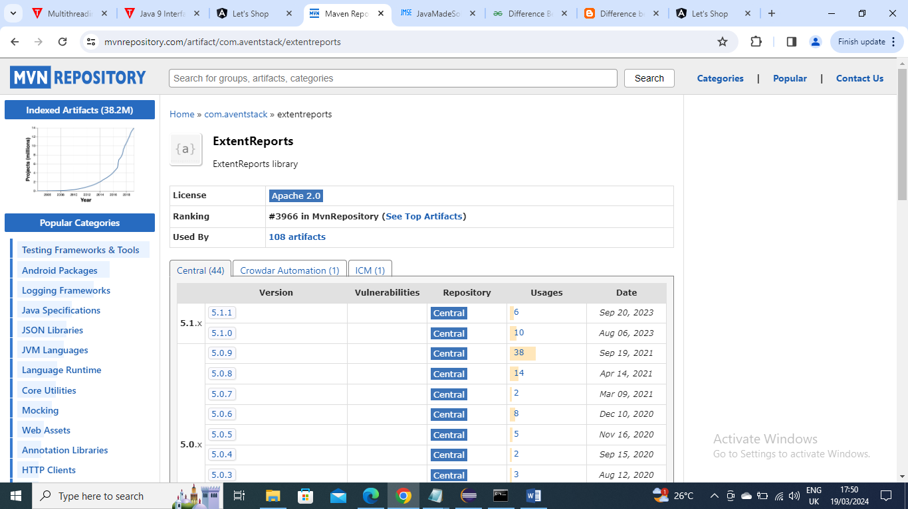

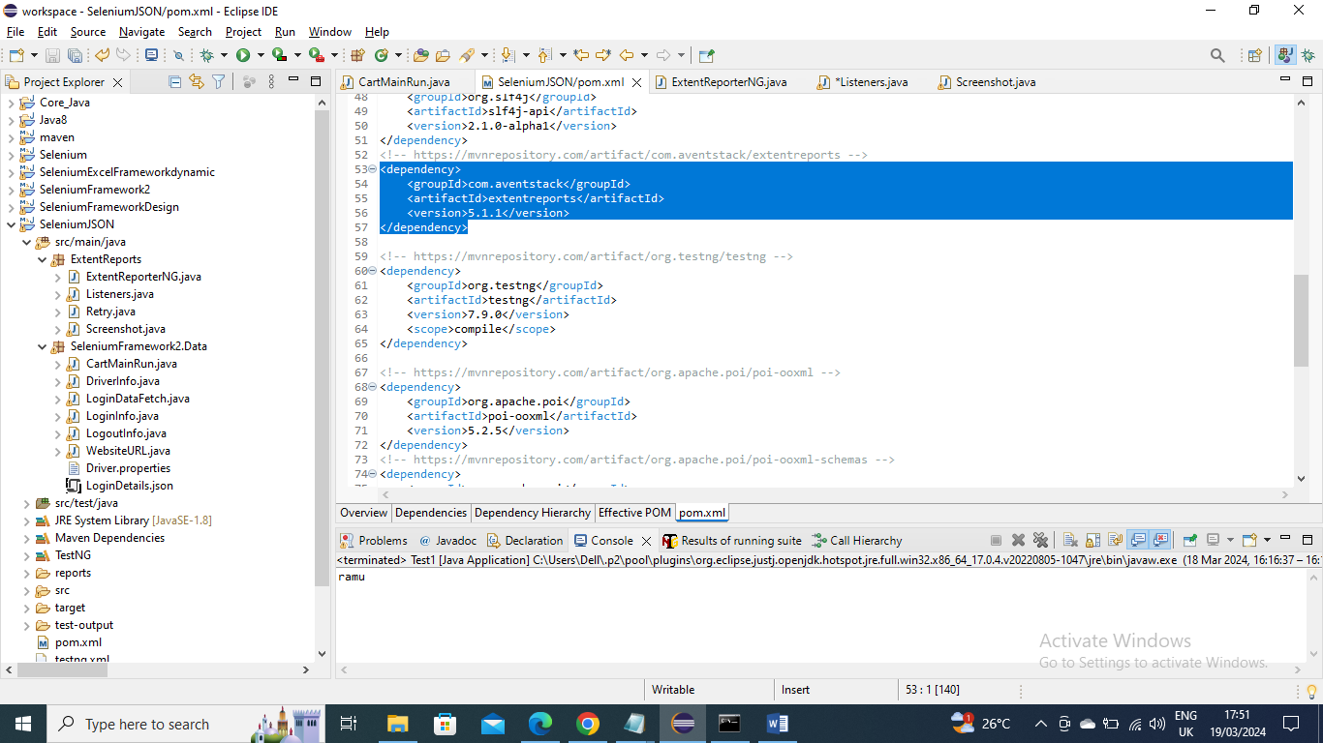

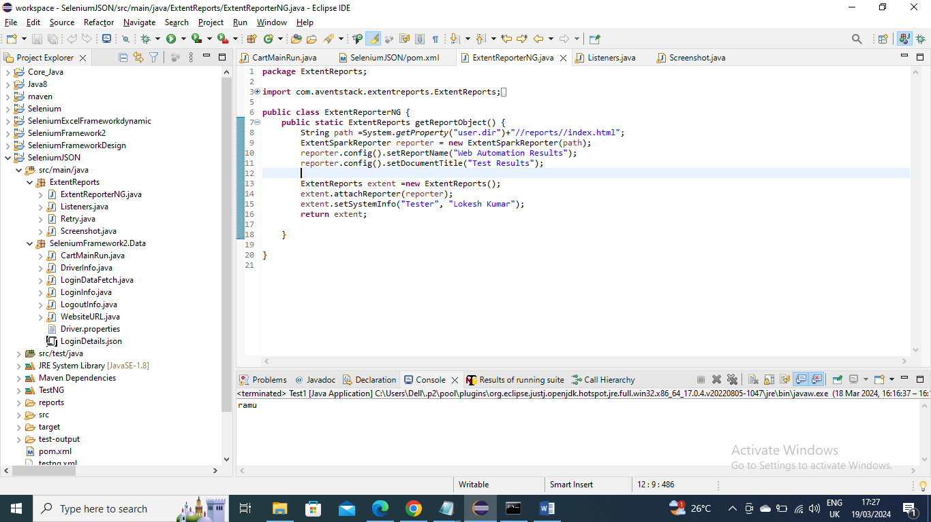

Listener – In below Listener class we mentioned that Extent report needs to be generated for every test and screenshot needs to be captured for every failure

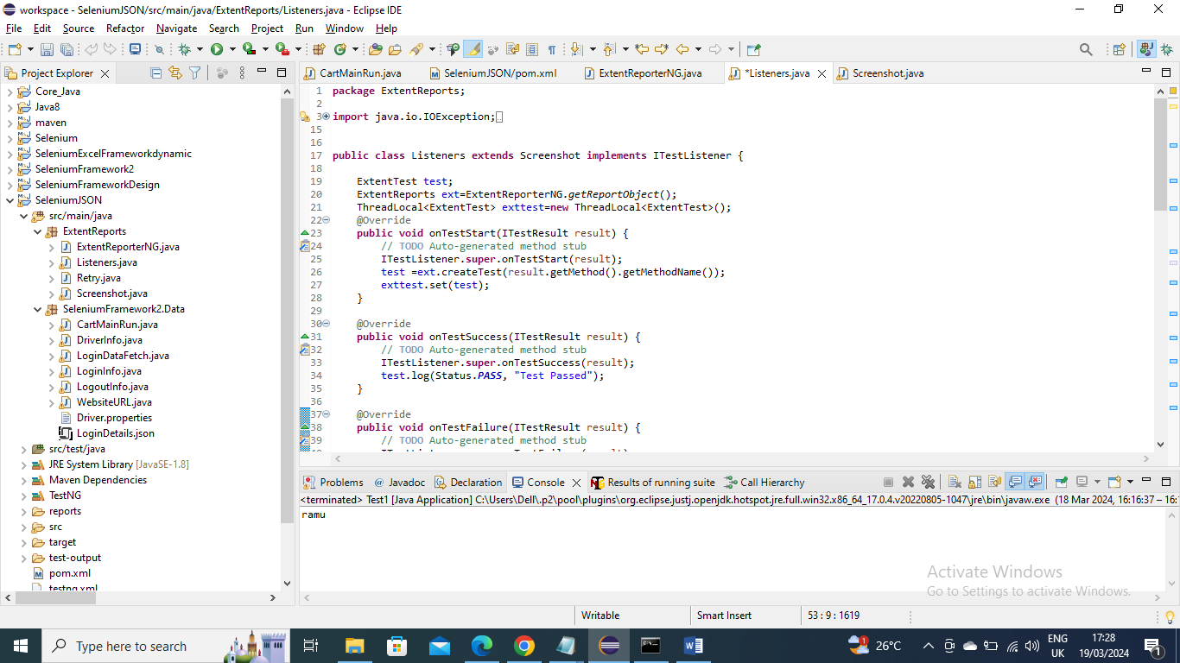

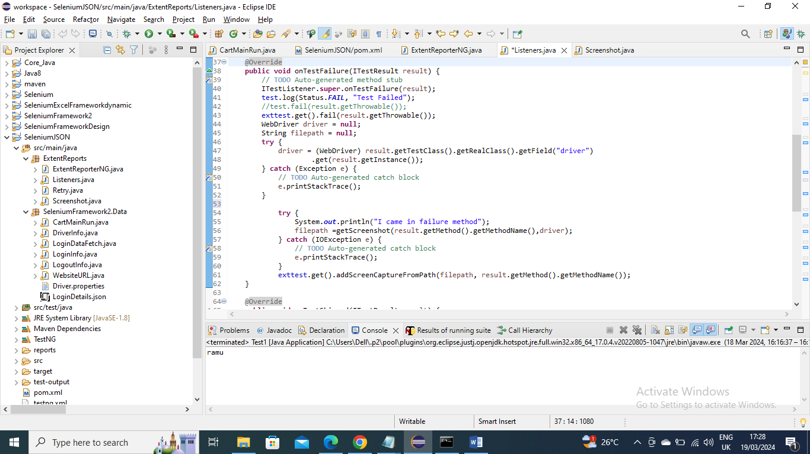

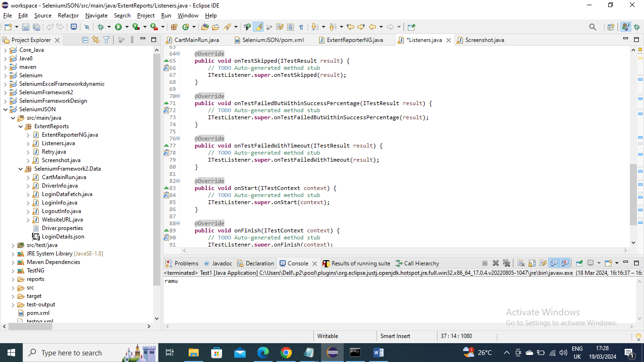

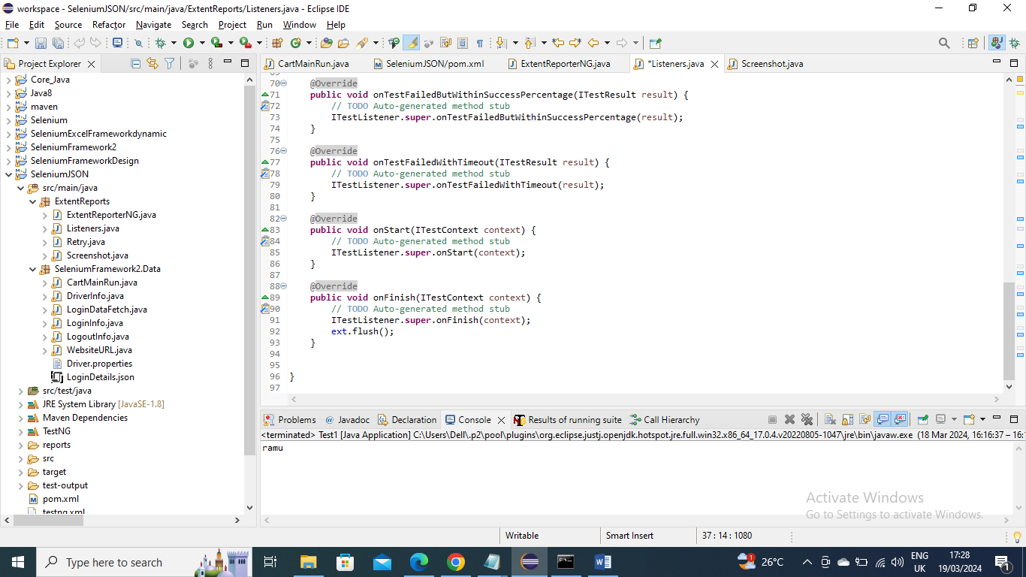

Now run the main Program using XML

Below are the screenshot and Extent (html) reports

Screenshot-

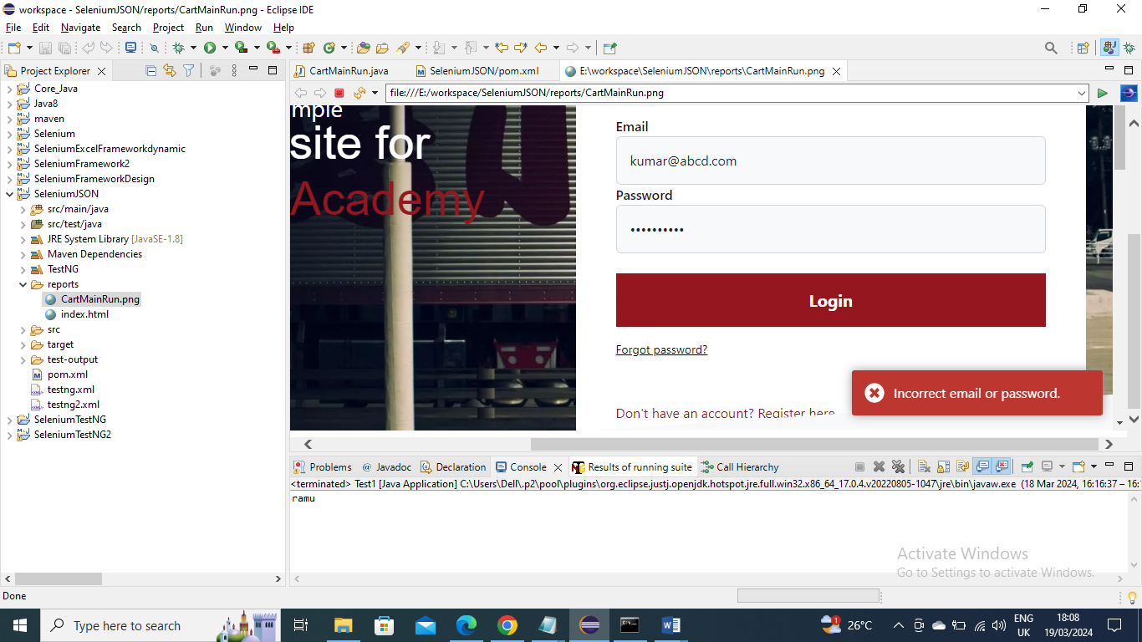

Extent (html) report –

